Problem 1

1. All binary numbers that contain 00 or 11

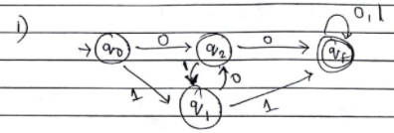

1. All binary numbers that contain a 1 in the 3rd location from the right (e.g.100, 10111, ...)

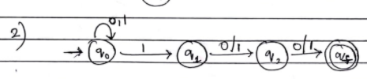

3. All binary numbers that can be divided by 3

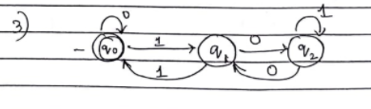

Problem2

Via subset construction, construct DFAs from all three NFAs that were constructed in problem 1.Please show step-by-step solutions.

